WEB Network Management

1.1 System Management
Connect master to PC by any Eth port of master，ensure that the computer network segment and Master network segment are in the same network segment (Master default is 192.168.1.6).
Open IE browser, input Master IP address(192.168.1.6) to login WEB interface. The default system name and password both are admin.
Note: When master is restored to the default settings, IP address is 192.168.1.6
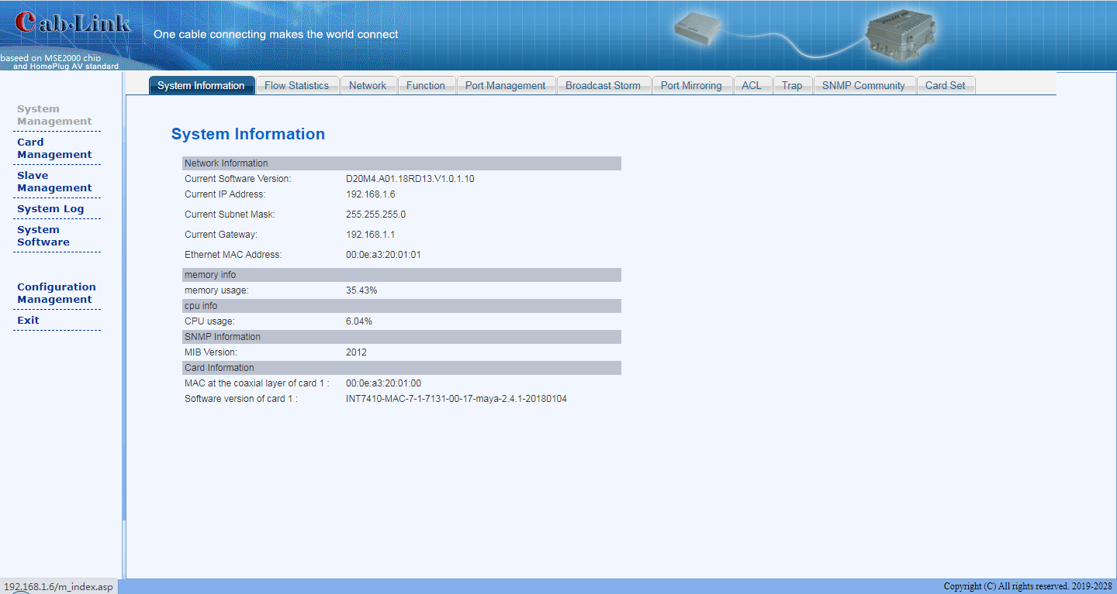
Here to show some information of master, eg, the current software version, IP address and MAC address, CPU usage, MIB, MAC at the coaxial layer and software version at transmission layer.
1.2 System Management---Flow Statistics
To check flow information
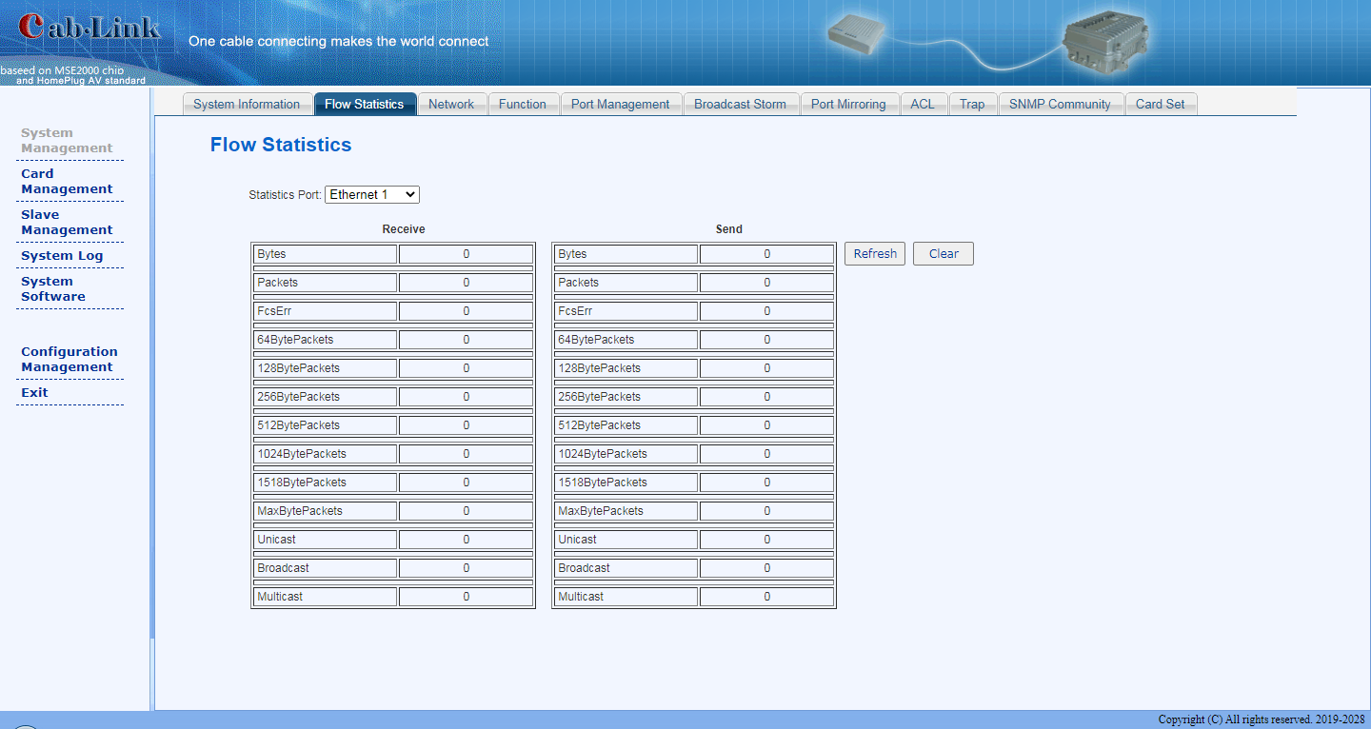

1.3 System Management---Network
Here the user can set IP address, subnet mask，gateway, Eth port vlan of master. Restart master after settings, and enter web by new IP address.
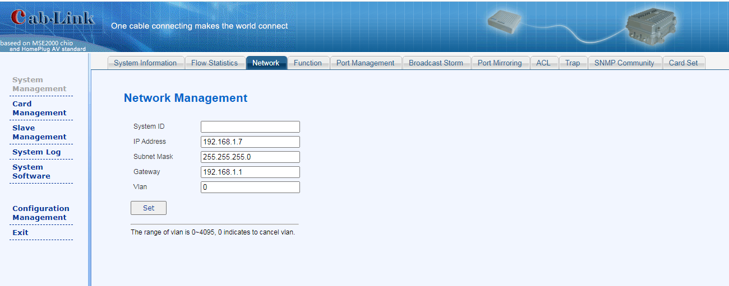

1.4 System Management---Function
Here the user can modify the related function configuration. Please read the introduction of related functions on the interface carefully (it is generally not recommended for customers to modify by themselves).
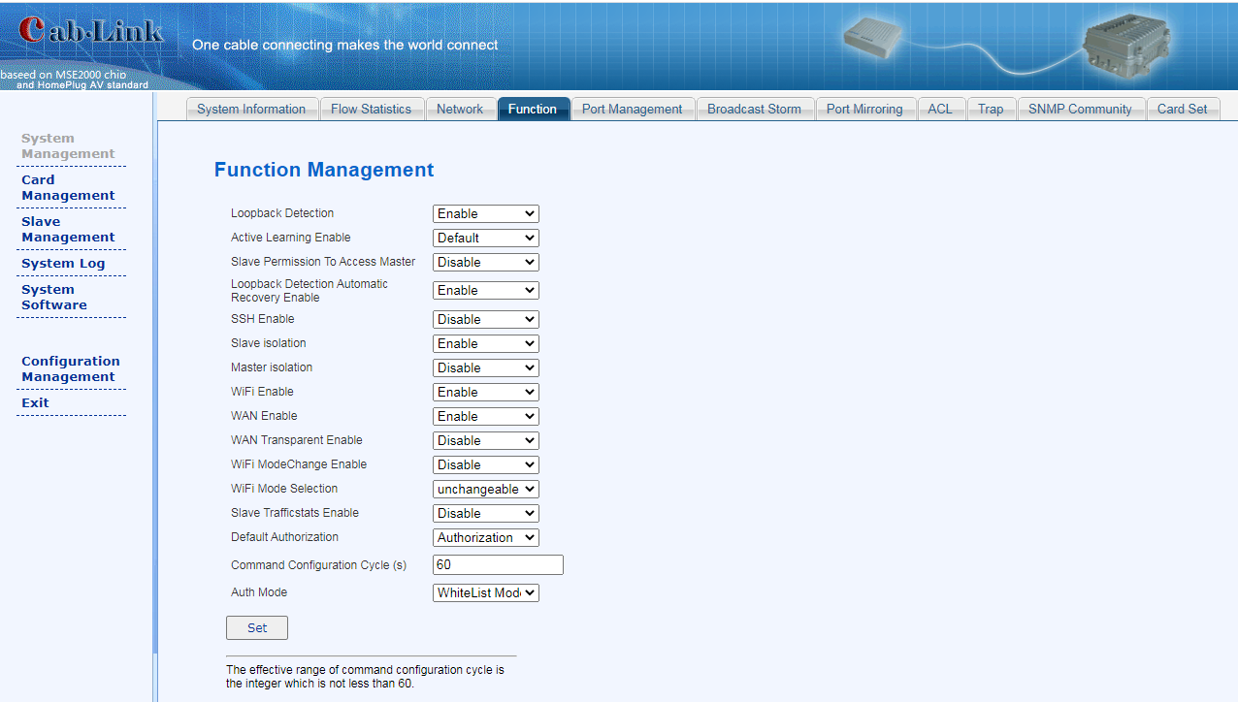

1.5 System Management---Port Management
Here the user can configure master Eth port: flow control, working mode, port enabling, port type. The working mode and port enable of the coaxial port can not be modified.
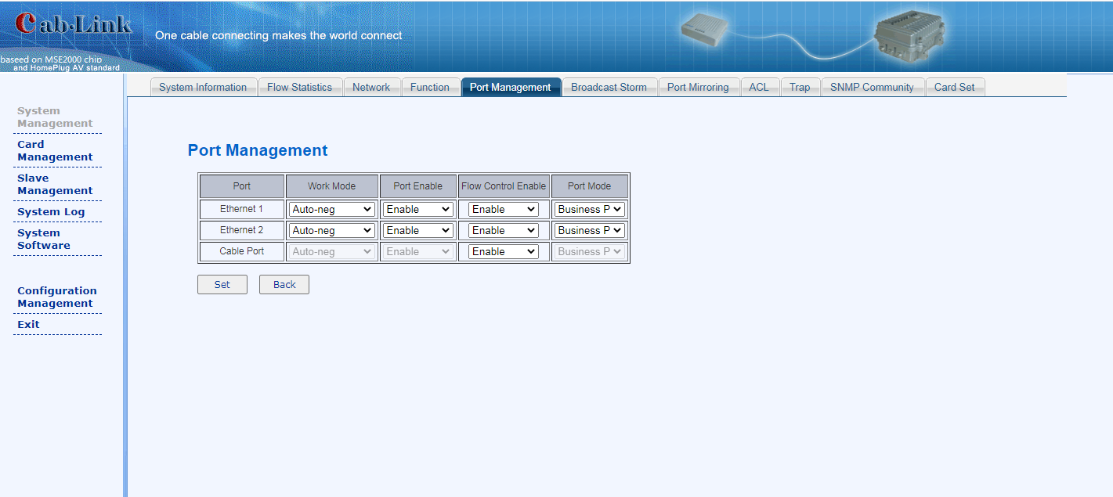

1.6 System Management---Broadcast Management
Here to set the suppression of broadcast packet, multicast packet and unknown packet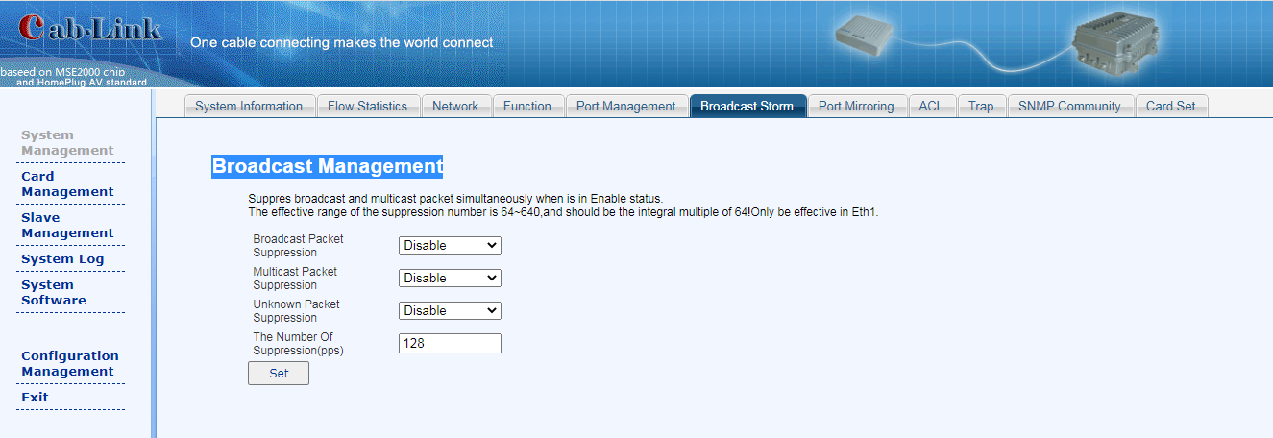

1.7 System Management---Port Mirroring
This function is mainly used to catch packet for the technical personnel
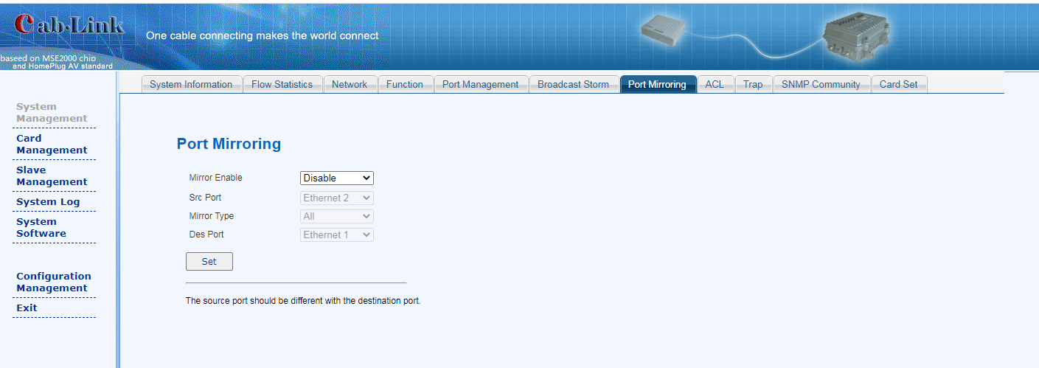

1.8 System Management---ACL
Here the user can set IP Filtering, MAC Filtering and Protocol Filtering
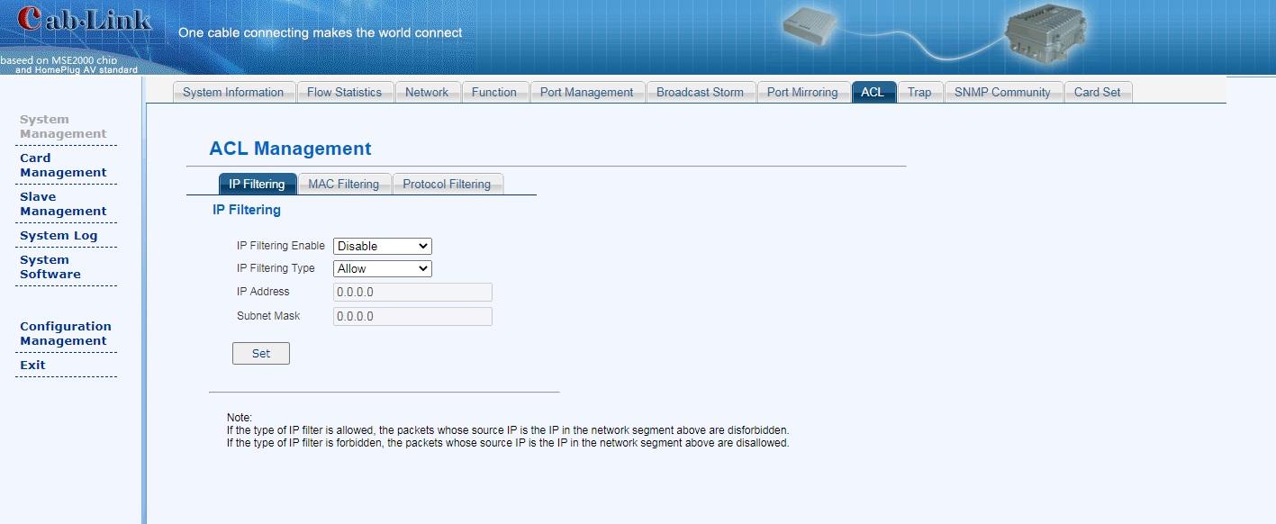

1.9 System Management---Card Set
Here the user can set Card serial Number, MAC, language, MIB, HFID. (it is generally not recommended for customers to modify by themselves).
(we have other types of masters which support multiple master modules, we call it card.)
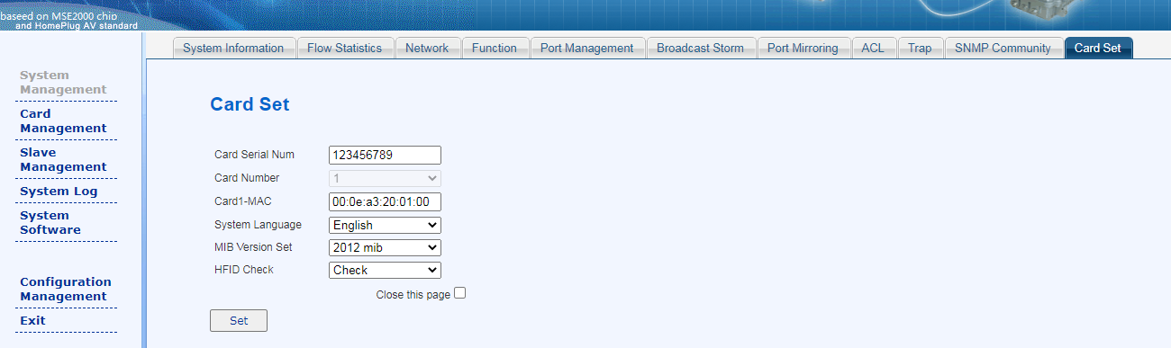

2.1Card Management---Slave online list
Here to show all online slaves information under this master
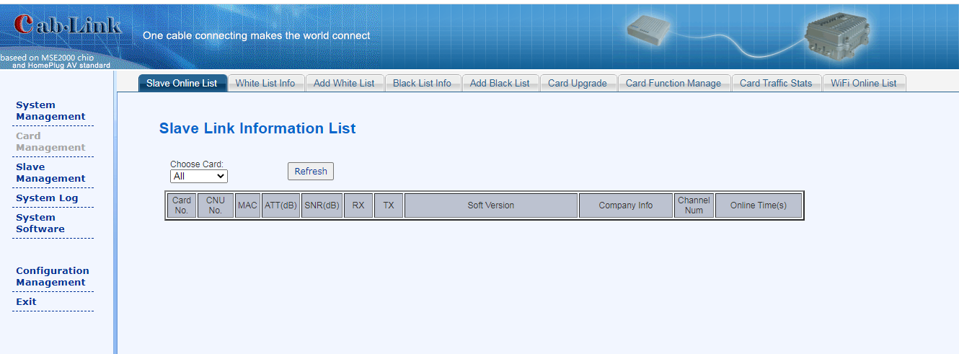

2.2 Card Management---White list info
Here to show information of both online and offline slaves under this master
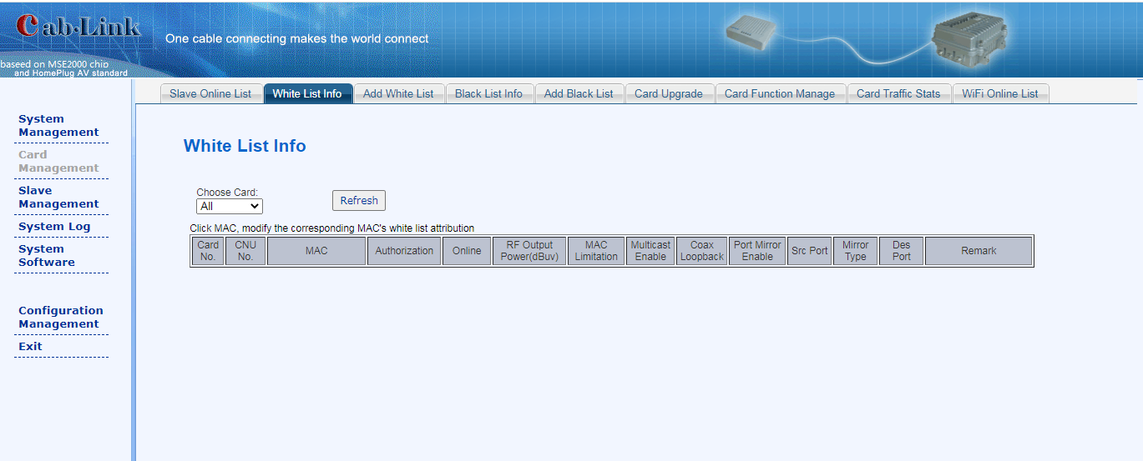

3 Slave Management---Slave Business
Choose slave MAC you want to modify, you can set speed limit and VALN. 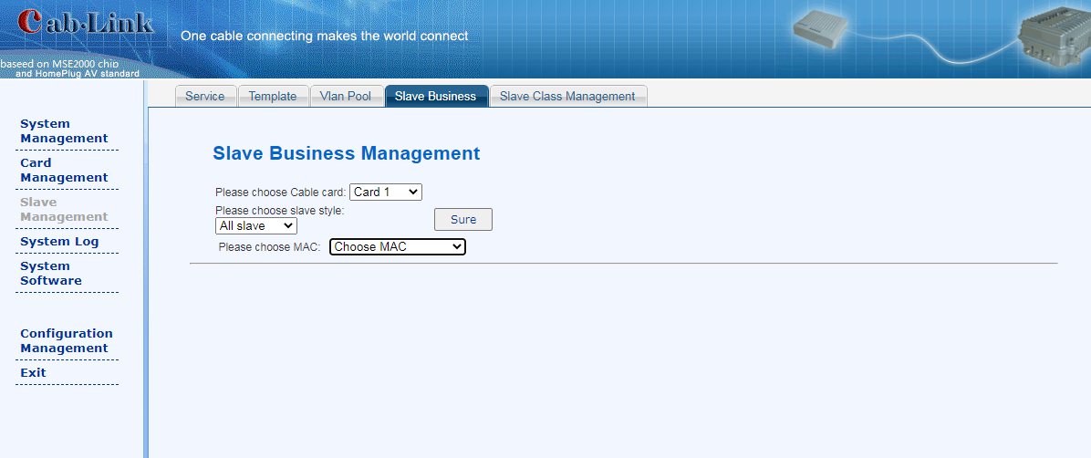

4 System log---System log
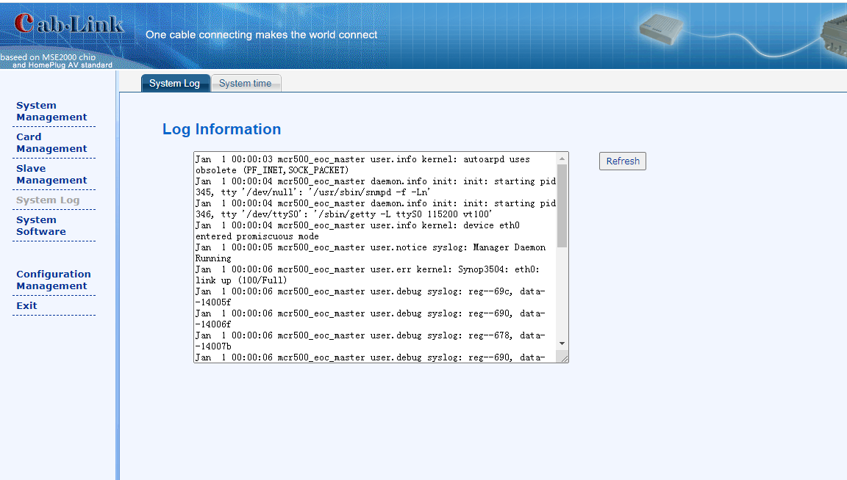5.1 System Software---Reboot
Here the user can reboot or reset master according to the different requirements.
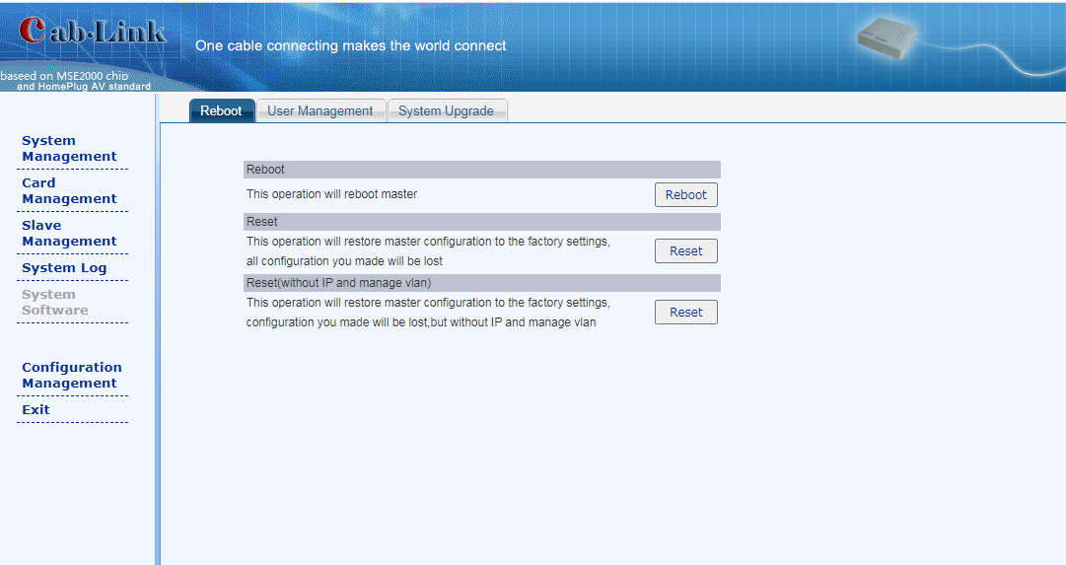

5.2 System Software---User Management
Here the user can modify login password.
